**A close up of a logo

Description generated with high confidence**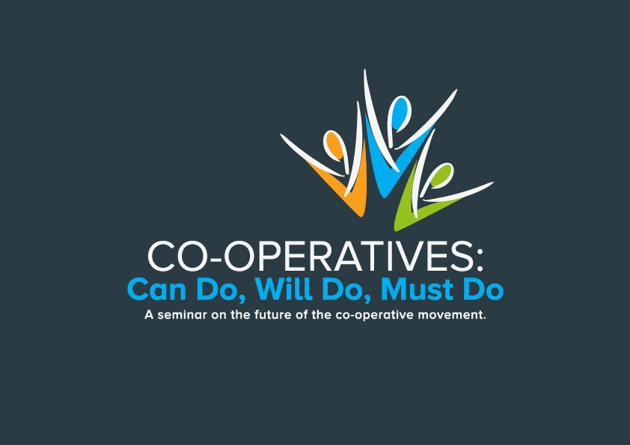

**EVENT “Co-operatives: can-do, will-do, must-do”**

**22nd and 23rd November 2017**

**Organised by Co-operative Alternatives**

**SCHEDULE**

**Wednesday 22nd November 2017**

Networking dinner starting at 6:30 pm, Belfast Castle.

6.30 Welcome and Introductions

Keith Brown - the Registrar of Credit Unions and I&P Societies

Ed Mayo – General Secretary of Co-operatives UK

**7.00 – 9.00 Dinner**

**SCHEDULE**

**Thursday 23rd** 11.00 - 16.30 in Girdwood Community Hub, Belfast

**11.00** - **Opening**/ Welcome from Cooperative Alternatives

**11.10** - **Who is in the room and what do we appreciate about co-operatives?**

**11.20 - The Power of Co-operation -** Key Note by Ed Mayo

**12.00 - Department for the Economy - “Economic Growth for Common Good”**

**12.15 - Belfast City Council - Go Social - Go Co-operatives**

**12.30** - **Insights, clarifications and questions**

**13.00 - Networking Co-operative Lunch**

**14.00 - Community Shares project - a funder perspective**

**14.15 - Co-operative Stories - take 1**

**14.40 - Co-operative Inspirations - take 2**

**14.50 - Co-operative Conversations**

**15.30 - Full Room Harvest Discussion**

**16.10 - Keynote Listeners Reflections**

**16.25 - Closing Remarks**

**16.30 - Close**