CO-OPERATIVE ALTERNATIVES
Planning Workshop Session Notes 1st May 2019
North City Business Centre, Belfast.

What we wanted to gain from a planning workshop
In attendance at this planning session were Tiziana O’Hara, Tony McQuillan, Amanda Johnston and Gavin Bell.

Maire Grattan from FutureSpark Coaching facilitated a planning workshop with the Co-Operatives Alternatives Board which it hoped would be useful to start strategic conversations on the following topics:
- To take an honest look at where we sit in the wider economic and community development narrative in NI in co-operative development.
- What does co-operative development look like to everyone? What is our commitment in delivering development our stakeholders need now and into the future?
- To identify what we feel is our core work and purpose moving forward in strengthening the co-operative moment in our region. How we might look as an organisation in the future?
There was a rich discussion across the above themes. Key points, questions for further thought and agreed actions have been collated from discussion below by Maire.
In addition to these notes, Maire has also added an appendix of the points forwarded to Tiziana’s questions emailed to Board members prior to the workshop about the role of Co-Operative Alternatives. These are included in Appendix A of this document.

What we learned from our Co-Operative Planning Workshop

Where feel that we are at now

What we are proud of achieving so far
As part of our scoping where we are now, everyone took time to review the achievements of Co-Operative Alternatives to date since it started work in 2013. Key achievements identified included:
- We have delivered a model that it works and definitely has a place.
- Generating £911k in 5 years from an initial investment of £360k!
- Delivering real outcomes with a very lean organisation. We have been really pro-active in showing how with very few people that we can deliver. Especially after losing Jo’s time, it was great that we kept things working and developing on the ground.
- We are happy with the number of co-operatives we have supported.
- Jubilee Farm in Larne is an amazing example of what has been created.
- We introduced to Northern Ireland the whole concept of community shares and made it part of the conversation.
- Recognising the level of commitment and expertise we have had on our Board. The Board has been a place where we have succeeded in bringing the philosophy of the co-operative movement and marry it with the practical. Here is a space where we have a meeting of perspectives.
- Proud of the diversity of business areas and sectors we have supported in our work. Look at our portfolio of projects spanning building and heritage, food/drink production, retail, agriculture, energy, sports and leisure.
- With the support from Building Change Trust (£40k) we were able to invest in skills development and have had 7 people trained to support Co-operative Alternatives.
- Sharing evidence and information to lobby for the co-operative movement. We contributed our knowledge about community shares to the DoFinance policy paper and have used impact reports to lobby (e.g. in providing information to Sinn Fein in policy discussions about the role of co-operatives).

What co-operative development looks like to us and our stakeholders

Stakeholder mapping for Co-operative Alternatives

As part of our discussion, we zoomed out to look at the ‘big picture’ of Co-operative Alternatives stakeholders. We plotted our range of stakeholders connections in the wider systems we operate within. Stakeholder mapping diagrams are included overleaf.
When we reviewed these maps, key questions surfaced relating to our stakeholder engagement such as:
- How can we work and connect more with the business sector and big businesses? Is there potential in the FairShares model with its multi-stakeholder approach and ethical ethos to link with the business sector? Are there other opportunities to connect differently – e.g. offering other pathways to businesses to move to a co-operative model as an option when a business is being sold on?
- How can we connect more with the general public and communities about the co-operative movement?
- Our existing co-operative members, how are we structuring our support for these co-operatives in terms of payment to us? We can spend a lot of time chasing fees in our engagement. How is the value of membership fees viewed by members?
- Based on our support for existing members and thinking about other leaders in the co-operative movement, how can we work with these stakeholders to encourage them to be champions of the co-operative movement helping development?

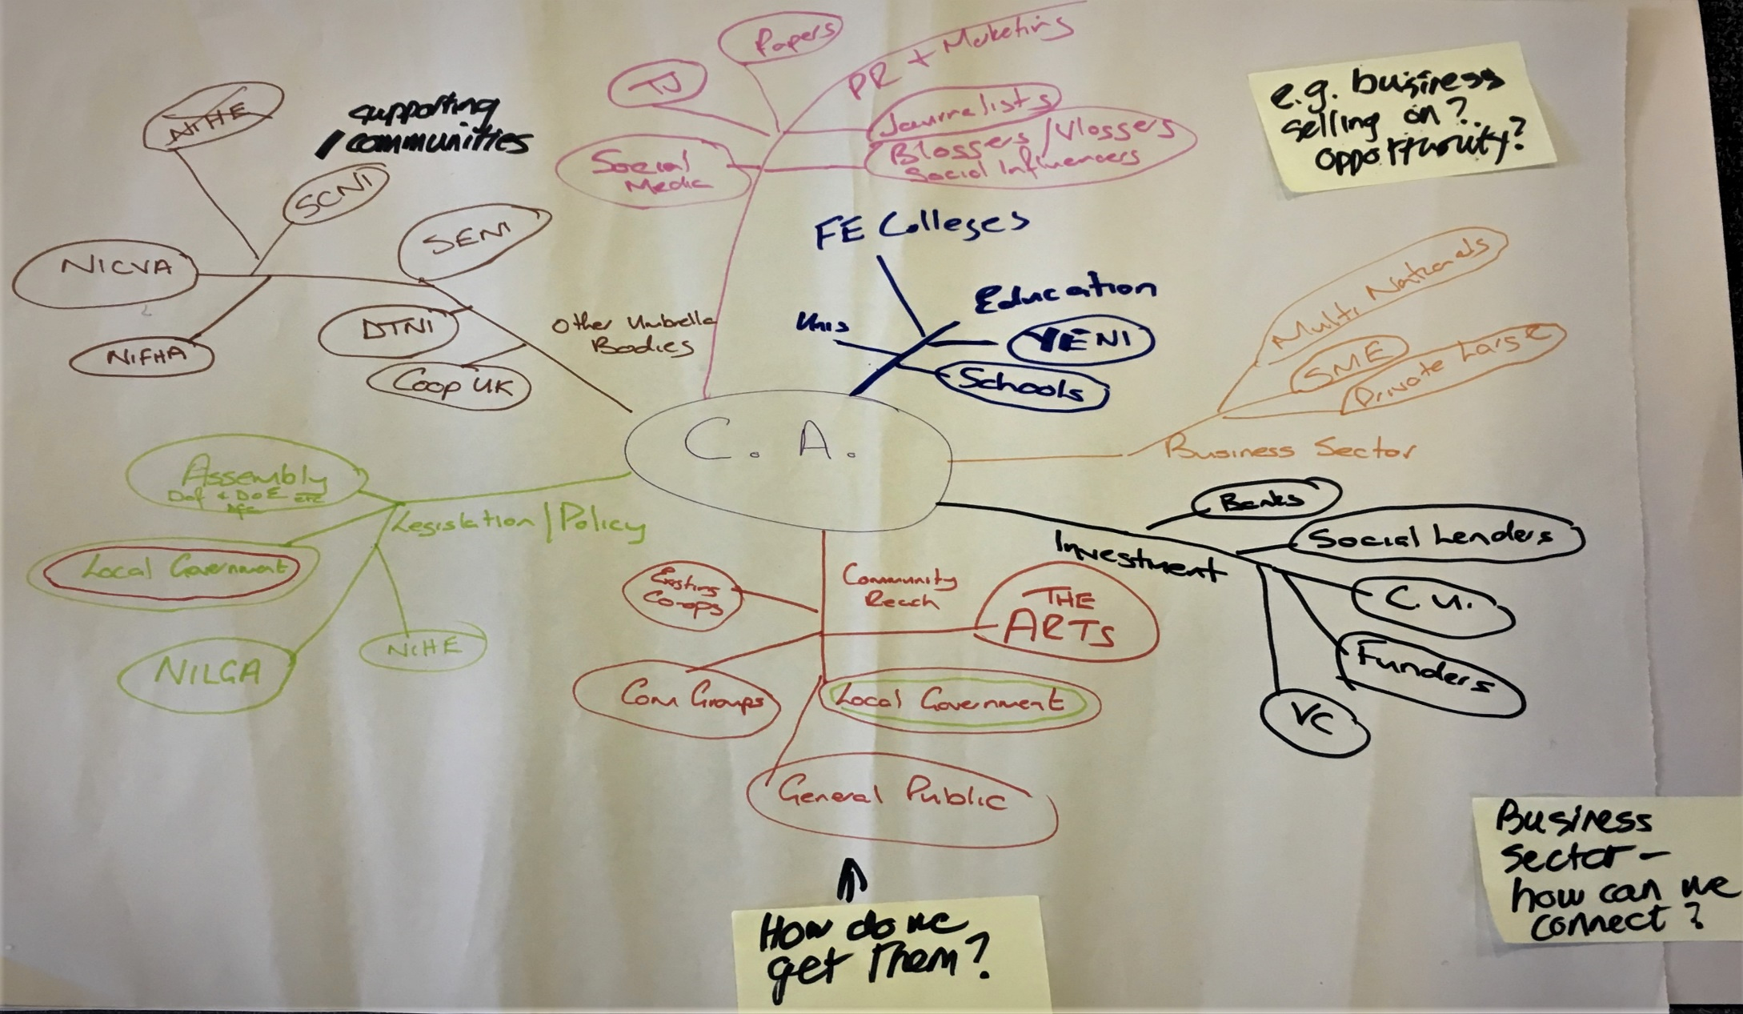

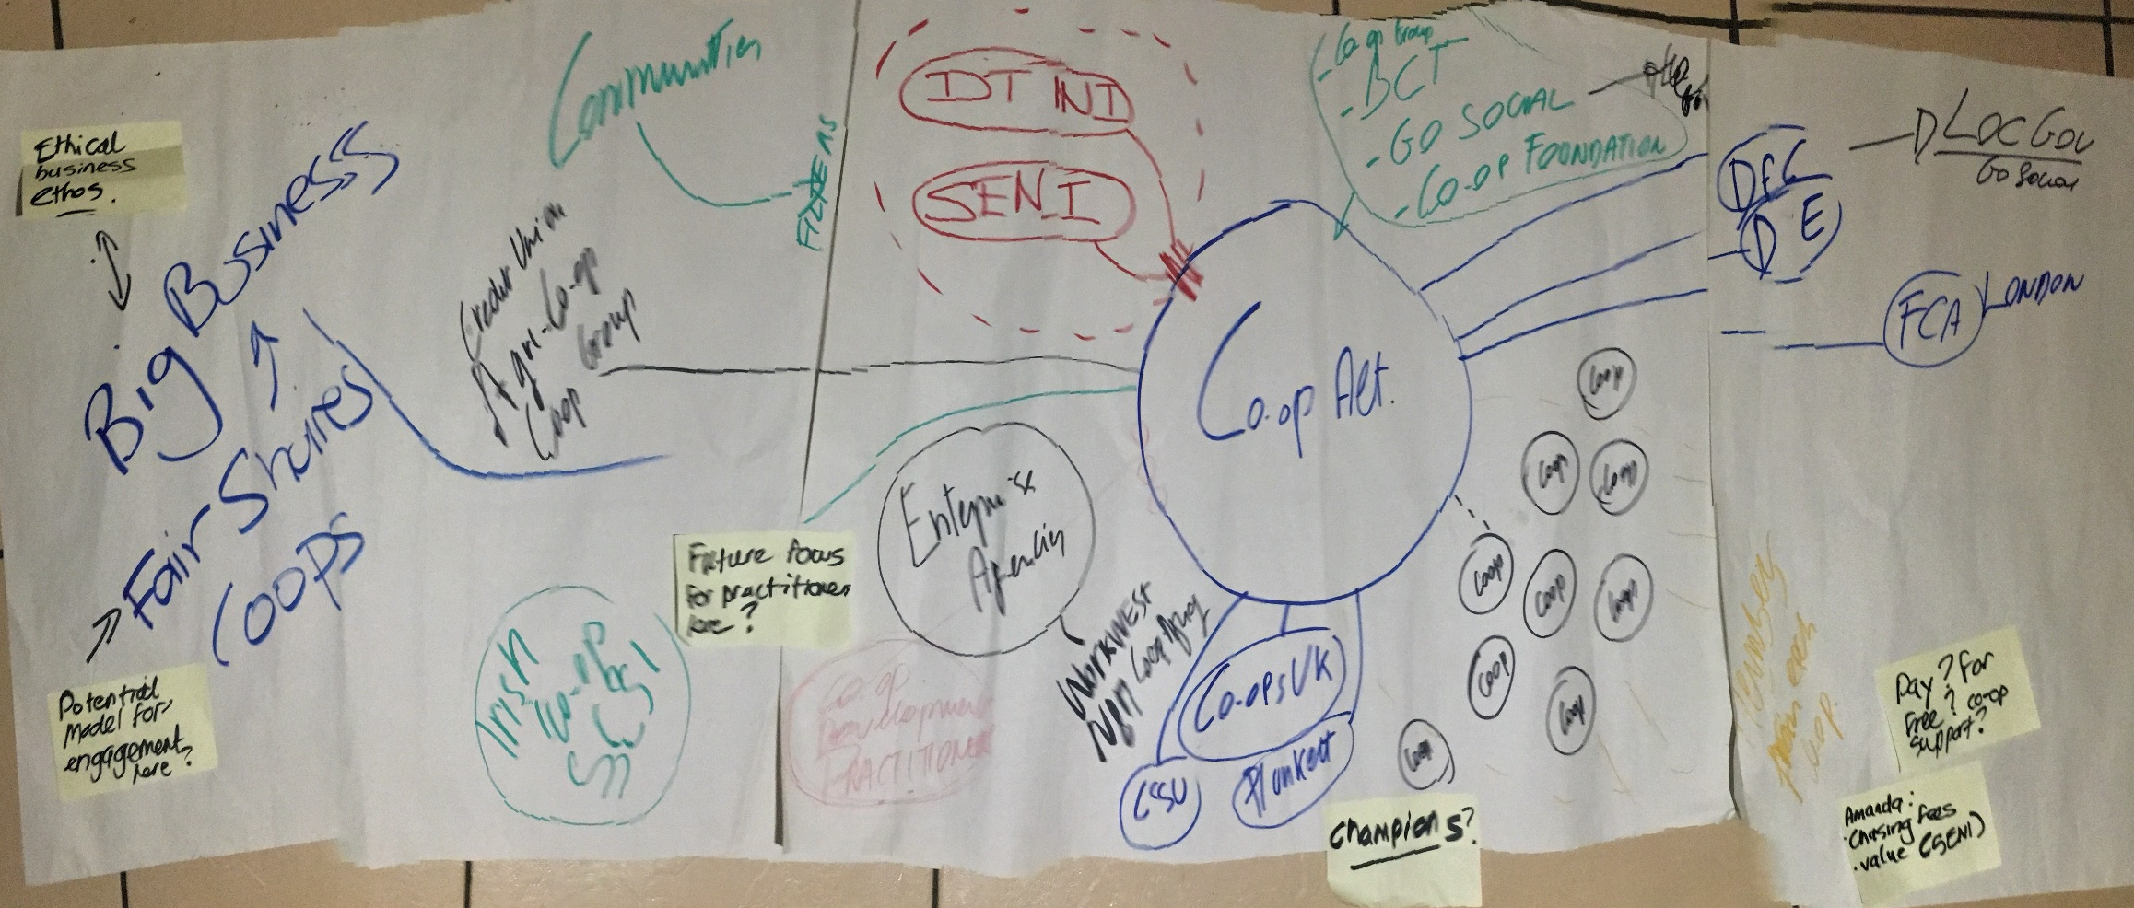

What does co-operative development look like working with stakeholders?

One of the points which emerged from looking at stakeholders in our sphere was an appreciation of the sheer array of existing and potential stakeholders. This triggered conversation about how we engaged, who we engaged with and how we needed to look at adapting our approach in targeting and working with different stakeholders. Key points from this discussion and questions to explore further are outlined below.

How we engage with our stakeholders – adapting our approach
There was an agreement that given our operational capacity and resources, that there were limitations on our ability to directly engage with such an array of stakeholders. For co-operative development, we needed to consider how we could work to optimise our influence and messaging. Ideas for this are listed below:
- Segmenting our stakeholders for influencing. Imagine our stakeholder groups as a power pyramid. We have a range of stakeholders with different levels of power and resources who we can work with to promote co-operative development. We need to think about how we connect with the different levels of stakeholders. We are limited in our capacity as a lean organisation as to what we can do directly but we can link for co-operative development. An example of how this could work is given in the diagram below.

- Educating others about co-operative development. It was highlighted that there were stakeholder groups who could be targeted with specific messages to widen the understanding of co-operative development and models. The charity sector was one stakeholder group where education about the versatility of co-operative development could be worked on. The example was given of how charities could be made more aware of the model of community shares as a way of generating income rather than for example entering into loans for sustainability. It was also felt that there were new groups to engage with outside agencies such as schools, colleges and universities.

- Linking with other stakeholders to message for cultural change. It was felt that the current models of capacity building to help ‘disadvantaged’ communities were staid and that in many cases, these approaches just simply don’t work. There is an opportunity here to work with other stakeholders to change the narrative about co-operative skills building in communities. We could look to see how we could promote with others the concept of co-operative skills building. In communities we want to encourage a belief in self-help and build community confidence by showing how co-operative skills working in the community can enhance capacity in a very positive way.

- Our role working with existing co-operative members. We want to be an inspiring force in our engagement with members. Key to our engagement should be looking to strengthen their skills and also helping to consolidate fledgling co-operatives (e.g. through supporting the development of their financial skills).

- Thinking differently about our networking role in co-operative development. Again, the diversity and connection between existing co-operatives was debated. We need to know more about what existing members want from us. Do we work to create a collaborative voice with existing members for the co-operative movement? How can we harness the existing network to support members: could older, more established co-operatives connect through us to help other newer members?

- Understanding stakeholders’ views about the concept of a co-operative movement. Did existing members and others understand the diversity of the co-operative movement? Do we know how members want to identify themselves as being part of a co-operative movement? There was, for example, the constitutional question of reciprocal trade and supporting others. We need to think about our role in networking and promoting the idea of a co-operative movement such as networking across member stakeholders. What we specifically want to do about this?

Identifying our core work moving forward

To finish our planning session, there were practical suggestions as to our next steps for work stemming from our planning discussion. Actions points are listed below.

- Identify our personal key strengths within Co-operative Alternatives. Each of us can provide different and complementary expertise, experience and skills. We should look at how through our individual contributions we can optimise on our strengths and to ‘spread the load’ more.

- Promote key messages of our successful work. Generating £911k over a short period is such a big message and we need to work more on getting this type of news out there.

- Sharpen our focus for stakeholder engagement. We need to decide and pare down who we link with and who we don’t chase. Once we have refined our target stakeholders, we then need to think about how we connect with them. In short, we need to target and work with the stakeholder groups who ‘get’ us. More targeted engagement with the stakeholders who matter most to us will help us decide and develop what we offer. For example, there are those 3000 people who already have invested in co-operatives here in NI, even connecting effectively with a small percentage of that group could yield supporters.

- Ethical positioning and social auditing of co-operatives. This should be a focus for our work as it could really assist exploring the impact of co-operatives and their development of working to the co-operative principles.

- Build practitioner specialisms here. We ourselves have different practitioner knowledge and specialisms. We have had interest from other people with specialist knowledge (e.g. heritage, arts etc.). Harnessing these interests, we could nurture people as specialist practitioners who then work with us to support diverse areas of co-operative development.

- Starting new conversations with existing stakeholders such as NIHE. Changes of leadership and others organisational developments can open up chances for new discussions about co-operative development. The Northern Ireland Housing Executive could be a potential funder for work and development and we should target them to initiate fresh conversations.

- Change how we communicate internally with each other. Today has been good to sit down and spend time with each other looking ahead. We should use different ways of keeping in touch such as a shared communication app where we can check in though mobile discussion. We want to look at how we keep in communication in general.

- Allocate work across our team. We can all contribute moving forward and at our next meetings let’s look at how we can divide up some of our work priorities.

Appendix A – thoughts on development from our e-mail exchanges

Prior to our workshop, to start thinking about the future, Tiziana sent three questions to the Board listed below. To capture valuable thinking about future development and the role of Co-operative Alternatives, responses to the questions are also given below. Many of the points highlighted were further discussed at our workshop.

- Co-operatives and co-operation skills are becoming more visible and in demand in our region. To what degree do you agree with such statement?
- Co-operative Alternatives is above all, about, co-operative development. To what degree do you agree?
- What do we need/want to do to ensure our relevance in the region?

Responses

From Amanda
- There has been great development through your work over the last few years but I don’t think this is very well known outside of the organisation/those interested in cooperatives.
- I would agree with the statement that this has been a primary focus for the organisation
- Be more visual as an organisation and our achievements each year (hard to do with current staffing issue I know).

From Tony
Question 1.
We have definitely made a difference in encouraging the growth of cooperatives here as evidenced by the increased number of coops. However, I am unsure whether cooperatives and cooperation skills are more visible and in demand.
I ask myself how do we measure the visibility/ demand for these skills and I don’t think we have a systematic process which we can repeat to provide measurable change over time. We may wish to look at that issue.
In the first phase of cooperative alternatives, we were funded to employ a resource to provide direct support to nascent coops and to get them ready for community shares. That was a great incentive and it clearly worked.
How now do we encourage the growth of cooperatives? I think we need to take a step back to look at how we might get more interest within the community for cooperative development.

One of the ways I believe is to support individuals or groups of individuals to understand the benefits of cooperation. While there has been public backing for the promotion of the Social Economy model with funding support, the cooperative model does not enjoy an equal public promotion.
In the absence of a working Assembly, I suggest that one of our tasks is to promote the benefits of cooperative development, the Cooperative Advantage, to Local Councils, the NIHE, the Department for Communities, other Departments. If we get an Assembly, we would promote the idea of a statutory Co-operatives Development Agency as recommended by the New Economics Foundation ‘Cooperatives Unleashed’.
Question 2.
We are a cooperative development organisation but if we are to achieve real change, we cannot be just another development agency.
I liked the quote from ‘Cooperatives Unleashed’, ‘‘…….co-operative development depends on creating networks and institutions that can mutually strengthen each other’ (Robin Murray 2010). One potential barrier to co-operative expansion is therefore the need to develop the political, social and cultural forces needed to popularise and embed a culture and institutional strategy that can ensure co-operatives aren’t, in the words of Raymond Williams, ‘simply trading organisations isolated from any struggle for alternative social purposes’.
I believe we have a role in extolling cooperative development as an alternative economic philosophy to the current free market led economic strategy and another role in combatting the image of cooperatives as an ethical alternative but not very effective business model.
Question 3.
I have covered this question to a large extent in answering Q1 and Q2. Those would be the major issues.
On a finer point, currently our web site identifies the direct services we can deliver. It may be worth considering providing more self-help guidance around basic cooperation skills e.g. communication, meeting and decision making, dealing with conflict, team working to reduce the pressure on our resources to deliver the direct services.
From Gavin
I agree with Tony that Coop A have assisted / facilitated the growth within the cooperative sector.
As discussed, it would be an opportune time to map all the existing coops north and south (ascertain their scope and presence) and see where the gaps are, and identify the input from Coop A.

In regards to promoting coops - I have been disappointed in the lack of interest from some of the elected members, who politically should be in favour of cooperative / mutual working. Perhaps it is time to move away from lobbying the bureaucrats for change and work directly with schools / colleges / universities, as those graduating have a better concept of life / enterprise / technology.
For instance - James's Locosoco project (which we can discuss tomorrow) has really taken off and he made the conscious decision not to go for local / central funding as he didn't want them to control / hamper progress with their lack of vision / aptitude for anything innovative, that doesn't fit with their agenda. His anarchistic approach is really paying off.
I think that there is an option of developing a social audit process that can be sold within the existing coops and built into developing coops. Surely, they should have some sort of ethical review of goods/services/production/government and management?

