|  |
| --- |
| Report to Members |
| 2015 – 2016 |

2015-16 was an interesting year for Co-operative Alternatives and for co-operative development in Northern Ireland.

**Progress with Community Share offers**

Three Societies successfully launched their second community share offers:

|  |
| --- |
| * Lacada Brewing Co-operative raised enough shares to reach £100,000 landmark thanks to the 250 new and existing members in October 2015. |
| * Boundary Brewery Co-operative have now 1050 members and raised an additional £156,000 from November 2015. |
| * Northern Ireland Community Energy (NICE) launched their offer in May 2016, and extended their deadline to the 30th June 2016. NICE was supported through the Community Shares Ready programme. |

Another two organisations successfully applied for the Community Shares Ready programme but did not proceed for a variety of reasons, including government changes to incentives for renewable energy, and reluctance of public agencies to transfer assets to community organisations. We are currently working with the Raglan Development and Renovation Society from Ballymena. The Raglan is one of only two new Societies registered last year and since.

In the Autumn statement 2015, the UK government changed the rules on Enterprise Investment Scheme (EIS), and Social Investment Tax Relief (SITR) making it much more difficult for activities to be eligible for tax relief on community shares, and impossible for renewable energy. This has effectively wiped out more than half of the market for community shares.

**“Growing Community Shares. Infrastructure Support in NI and UK 2009 – 2015” RESEARCH.**

Our research published in August 2015 showed that:

|  |
| --- |
| Research Key Findings |
| Lottery England support for social finance would be the equivalent *pro rata* in Northern Ireland to £965,000 per year for ten years |
| For every £1 funding to Co-operative Alternatives, £2.28 was raised through community shares - a very high rate of return on social investment. |
| Community shares in Northern Ireland could achieve much more with more resources. Northern Ireland has had 6 community share offers - 12% less than expected compared to UK figures. This reflects belated funding of a dedicated community shares programme. |
| Collectively, these community share offers have raised £2.58m - two and a half times more than the UK average. This shows a strong appetite to invest in NI through community shares. |
| Northern Ireland community share offers have recruited 2,089 members - 25% more than the UK average. This shows a strong desire of people and organisations to co-own community enterprises through community shares. |
| There are dozens of unique economic and social factors in Northern Ireland that disadvantage community shares compared to England, Wales and Scotland. |
| For the decade to 2013, there was no dedicated funding for co-operative development in Northern Ireland. |

Our report was distributed to decision makers including our Advisory Group, the press and MLAs. Meetings were held with the Lottery, an All Party Group and several government departments. However, the funding situation has not improved. All other nations of the UK enjoy state funded co-operative development agencies. So it is disappointing to note that the government of Northern Ireland has not been able to find a pound that can be dedicated to the development of co-operative businesses.

**Support for Co-operatives**

The Lottery, through the Building Change Trust, has commissioned Coop Alternatives to continue the Community Shares Ready programme. With a further £82,885 over two years.

Co-operative Alternatives continues to partner with the Plunkett Foundation and their rural co-operatives programme, benefitting community owned enterprises from Omagh to Cloughmills and Downpatrick.

Co-operative Alternatives continues to work with the Growing Together project, a partnership UK-wide lead by the Federation of City Farms and Community Gardens, helping community growers to become more financially sustainable. During 2015, we helped delivering four workshops and events to local communities as well as contributing to the Advisory Board.

Co-operative Alternatives is also the preferred provider of the HIVE, a UK-wide cross sectoral programme, funded by the Co-operative Bank, of support for co-ops and community businesses.

**Board and Strategy**

The Board of Co-operative Alternatives is much stronger than a year ago. It has consulted members and stakeholders, and developed a strategy for the organisation.

The Board have shown tremendous commitment and kindly contributed a significant amount of voluntary work for the organisation.

Membership of Co-operative Alternatives itself grew to 29 people and organisations in 2015, but has steadied since then. With the new website [www.coopalternatives.coop](http://www.coopalternatives.coop) we aim to increase contacts with our support base and disseminate our work more.

The Board of Directors 2015/2016 consisted of Jo Bird, Charlie Fisher, Karen Arbuckle, Tony McQuillan, Juliet Cornford, Teri Kelly, Anne Molloy and Tiziana O’Hara.

**This report was jointly prepared by Jo Bird (Chair) and Tiziana O’Hara (Project Manager) – June 2016**

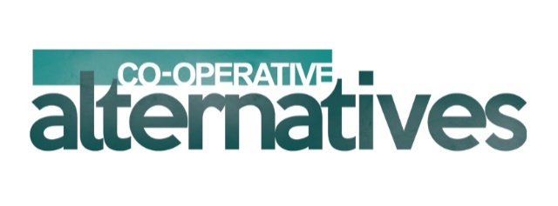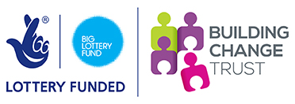

**Our thanks to the Building Change Trust, our partners and collaborators**

**Strategy Going Forwards**

The Board has spent a considerable time in the last quarter to think further about a number of issues relating to the future, the funding for our work and the opportunity out there for the continuation of a dedicated project/support work on community shares and co-operative development. With the support of Louise O’Meara from the Institute of Social Change, we are able to present you an outline strategy for the next three years 2016 - 2019.

|  |
| --- |
| Co-operative Alternatives Outline Strategy 2016 - 2019 |
| Vision Our vision is of a strong co-op movement connected across the island of Ireland and doing business in a fair, just and ethical way. |
| Mission Our mission is to develop, research and represent the needs and realize the potential of existing and emerging co-operatives on the island of Ireland. |
| Key areas of focus over the next three years  * Deliver a range of high quality developmental supports to coops. * Promote co-operatives and raise awareness of co-operative models. * Research and represent the needs, benefits and potential of co-operatives. * Recruit and engage Co-operative Alternatives’ membership and grow it into a network of members that support each other. |