Growing Community Shares:
Infrastructure support
in Northern Ireland and UK, 2009-2015

Report by
Jo Bird
Co-operative Alternatives
August 2015

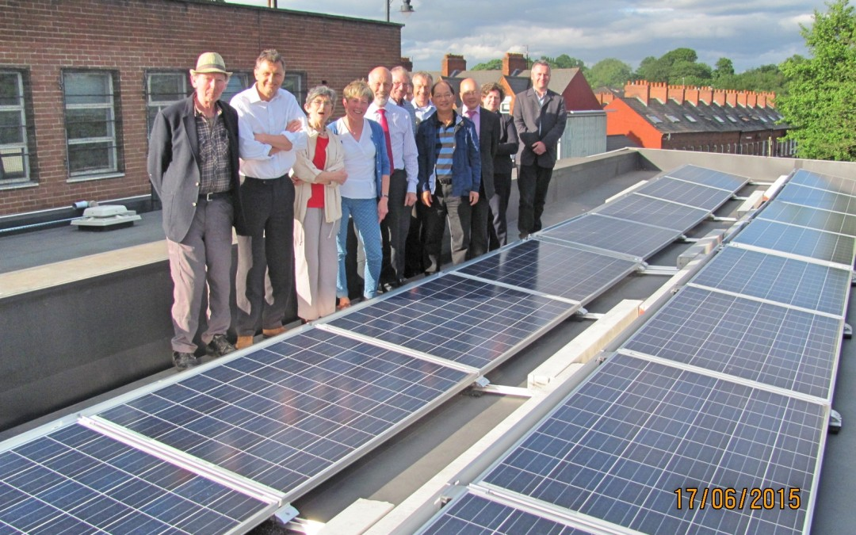
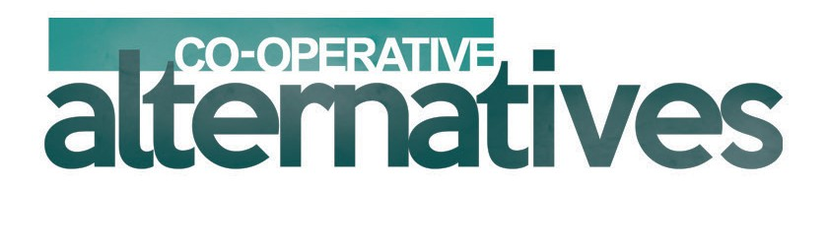
Figure 1 Northern Ireland Community Energy raised £150,000 through community shares from 76 members, to install free solar panels and substantially reduce electricity bills of community organisations, including the Chinese Welfare Association pictured above.

Contents

Section Page

1. Executive Summary and Key Findings 3

2. Growth and Distribution of Community Shares 5

3. Infrastructure Support for Community Shares 7
3.1 Methodology
3.2 Dedicated community shares programmes in the UK
3.3 New programmes with a significant element of community shares – England only
3.4 Programmes with a significant element of community shares – “UK-wide”

4. Community Shares Offers in Northern Ireland 10

5. Comparing Community Shares Outcomes 11

6. Unique Factors for Community Shares in Northern Ireland 12

7. Conclusions and Recommendations for Action 15

About the Author 15

- Executive Summary and Key Findings

Community shares are an innovative and increasingly valuable way to start, expand and run community owned businesses – such as shops, sports clubs, renewable energy, community assets and services, as well as innovations like green burials. Their purpose is community benefit – rather than private profit.
Community shares have unique advantages over loans – including patient capital invested for at least three years for little or no interest. The UK government matches most purchases of community shares, bringing fresh income to communities. HMRC’s Seed Enterprise Investment Scheme refunds 50% of investment from individuals.
The rapid growth in community shares in Britain continues to be supported by infrastructure agencies such as the Community Shares Unit (CSU), and the Plunkett Foundation. Before the Community Shares Unit existed, there were around 5 community shares offers per year - since 2009, the average is 55 offers per year. Support for and from infrastructure agencies, and community share offers, are remarkably unevenly distributed across the regions and nations of the UK.

The Building Change Trust asked Co-operative Alternatives to report on known support for infrastructure organisations, and explore differences between the nations of the UK.

Since 2009, Co-operatives UK have delivered £1 million of community shares programmes in England and Wales, through the Community Shares Unit.
The Big Lottery and other funders are clearly convinced that community shares are an integral and essential part of their agenda going forwards. Just three programmes - Power to Change, the Access Foundation and Big Potential –have Lottery and government funding in England of over £270 million for community enterprise and investment readiness.
There are no equivalent programmes for community enterprise in Northern Ireland. If Lottery funding was proportionate per head of population, funding for Northern Ireland would be £9,643 million or £964,000 per year for ten years.

Co-operative Alternatives and five Co-operative and Community Benefit Societies have proven the community shares model works in Northern Ireland.
In the last year, Co-operative Alternatives has supported four Co-operative and Community Benefit Societies that have launched community share offers. Two craft brewery co-operatives, a solar energy society and a green burial society. Together, they have raised over £365,000 by recruiting 800 members.
For every £1 funding to Co-operative Alternatives, £2.28 was raised through community shares - a very high rate of return on social investment
Community shares in Northern Ireland could achieve much more with more resources. Northern Ireland has had 6 community share offers - 12% less than expected compared to UK figures. This reflects belated funding of a dedicated community shares programme.
Collectively, these community share offers have raised £2.58m - two and a half times more than the UK average. This shows a strong appetite to invest in NI through community shares.
Northern Ireland community share offers have recruited 2,089 members - 25% more than the UK average. This shows a strong desire of people and organisations to co-own community enterprises through community shares.
There are dozens of unique economic and social factors in Northern Ireland that disadvantage community shares compared to England, Wales and Scotland.
For the decade to 2013, there was no dedicated funding for co-operative development in Northern Ireland.
Northern Ireland’s poverty rate is high at 24%. Thus savings or disposable household income available to buy community shares is lower than any part of the UK outside London.
£4 million funding from the government of Northern Ireland was awarded to 11 new Social Enterprise Hubs in 2014. Co-operative Alternatives has offered its services to all Hubs, and 4 have relied on our experience in co-operative development. However, the Hubs have only identified and referred one client to Co-operative Alternatives. The Hubs have not advised new or existing co-operative nor community benefit societies. No existing Societies have applied advice from the Social Enterprise Hubs towards community shares.
It is recommended that the Lottery and government in Northern Ireland learns from best practice in Britain regarding community enterprise and investment readiness.
Pro-rata funding would be £964,000 per year for ten years for a programme with a significant element of community shares.
Such a level playing field may be enough to overcome dozens of unique factors for community shares in Northern Ireland.

- Growth and Distribution of Community Shares

Across the UK, community shares are an innovative and increasingly valuable way to start, expand and run community owned businesses – such as shops, sports clubs, renewable energy, community assets and services, as well as innovations like green burials. Their purpose is community benefit – rather than private profit.
From 2009 to mid 2015, there have been over 246 community share offers in the UK. These offers raised at least £60 million from 60,000 members (Inside The Market Report, Co-operatives UK). Most members had not bought shares in anything before.
Many organisations use community shares to leverage grants and loans, but some do not. Community shares have unique advantages over loans.
- Providers of community shares invest for at least three years and usually much longer, for little or no interest. Providers of loans require regular and complete repayment, plus market rates of interest.
- The UK government matches most purchases of community shares, bringing fresh income to communities. HMRC’s Enterprise Investment Scheme (EIS) and Seed EIS refunds 30% or 50% individual investment respectively. New Social Investment Tax Relief will also refund 30% to individual investors.
- Community shares uniquely benefits co-op and community benefit societies. This innovative legal form enshrines democracy through one member, one vote.
The rapid growth in community shares in Britain continues to be supported by infrastructure agencies such as the Community Shares Unit (CSU), and the Plunkett Foundation. Agencies are funded by the Department for Communities and Local Government, Department of Energy and Climate Change, the National Lottery and others. Before the Community Shares Unit existed, there were around 5 community shares offers per year - since 2009, the average is 55 offers per year.

Support for and from infrastructure agencies, and community share offers, are remarkably unevenly distributed across the regions and nations of the UK.

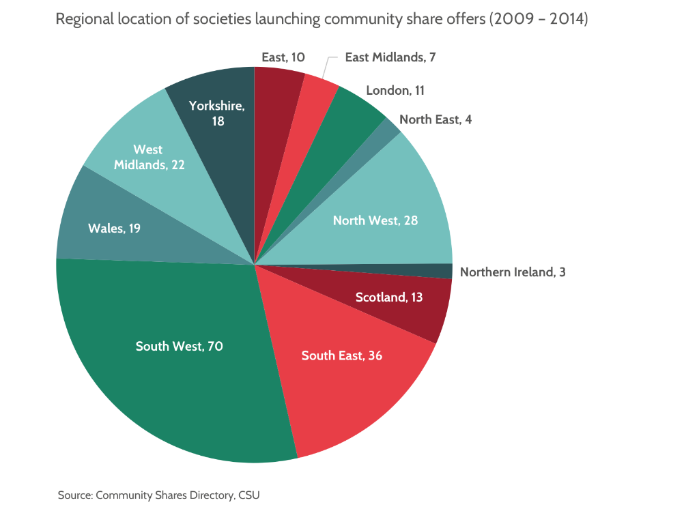
In Northern Ireland, the Community Shares, Ready! programme started in 2013. The dedicated programme is funded by the Building Change Trust for three years, and delivered by Co-operative Alternatives.

The Building Change Trust asked Co-operative Alternatives to report on known support for infrastructure organisations, and explore differences between the nations of the UK.

- Infrastructure Support for Community Shares

3.1 Methodology

This report researched known programmes for community enterprise either wholly or significantly through community shares. Research was conducted through internet searches from May to July 2015. In addition, infrastructure agencies were asked by email and in person, to list the financial support received in recent years, primarily for purpose of community shares.

3.2 Dedicated community shares programmes in the UK
There are dedicated community shares programmes in England, England & Wales, Scotland, and Northern Ireland but not in Wales alone. Since 2009, Co-operatives UK have delivered community shares programmes in England and Wales, funded by over £1 million.
Table 1: Nation specific programmes dedicated to community shares
Programme | Infrastructure agency | Funding | From | Duration | Remit
Community Shares programme | Co-operatives UK | c£150,000 | Cabinet Office and DCLG | 2009-11 | England & Wales
Community Shares Unit | Co-operatives UK | £590,000  £200,000  £110,000 | DCLG  DCLG  DECC | 2012-15  2015-16  2015-16 | England
Community Shares Scotland | Development Trusts Association Scotland | £800,000 | Big Lottery Fund Scotland and  Carnegie UK Trust | 2014-16 | Scotland
Community Shares, Ready! | Co-operative Alternatives | £235,000 | Building Change Trust | 2013-16 | Northern Ireland
 | Total | 2,085,000
3.3 New programmes with a significant element of community shares - England only
The Big Lottery and other funders are clearly convinced that community shares are an integral and essential part of their agenda going forwards.

Early in 2015, the Big Lottery announced funding to The Power to Change Trust to support community enterprise in England, with £150 million from 2015 to 2025. Community shares are used by 38% of their “inspiring examples”.

The Access Foundation for Social Investment was launched in early 2015 to support social enterprises and charities in England to access to social finance, for a decade. It has been funded with over £100m from the Big Lottery, Big Society Capital and Cabinet Office “to enable smaller social sector organisations access the types of finance they need to develop”.

Big Potential programme is funded by the Big Lottery through Social Investment Business, from 2014. The programme has £20 million for community organisations in England, to consider social investment and become investment ready. Community shares are promoted alongside other forms of social investment such as crowdfunding donations and loans.

These three programmes - Power to Change, the Access Foundation and Big Potential –have Lottery and government funding of over £270 million for community enterprise and investment readiness.

There are no equivalent programmes in Northern Ireland. If Lottery funding was proportionate per head of population (which it is not) pro rata funding for Northern Ireland, would be £9.64 million or £964,000 per year for ten years.

In Northern Ireland, the Lottery will soon launch a £60m grant fund over 5 years, called People and Communities. Co-operatives and mutuals are explicitly eligible but it is not yet clear whether this fund will encourage community shares nor explore social investment.

It is recommended that the Building Change Trust, Lottery and government in Northern Ireland learns from best practice in Britain regarding community enterprise and investment readiness. Pro-rata funding would be £964,000 per year for ten years for a programme with a significant element of community shares. Such a level playing field may be enough to overcome the dozens of unique factors for community shares in Northern Ireland.
3.4 Programmes with a significant element of community shares - “UK-wide”
Some programmes are funded to be UK-wide but do not, or only belatedly, deliver with organisations in Northern Ireland. The table below shows how programmes consistently fail to reach organisations in Northern Ireland, unless they work with agencies based in NI.
Table 2: “UK-wide” programmes with a significant element of community shares
Programme | Infrastructure agency | Funding | From | Duration | Delivery with orgs in NI
Co-operative Enterprise Hub | Co-op Devlpmt Agencies consortium inc Co-op Alternatives | £5m | the Co-operative Group | 2008-14 | Yes. In 2 years, 2012-13.
Low Carbon Communities Challenge | Specialist Support Team consortium | £10m | DECC, DETI and Welsh government | 2010-12 | One. Glencraig Camphill
Supporters Direct | Supporters Direct | c£800,000 pa | Football Foundation | 2002 – ongoing | None
Frontline support esp for shops, woodland and rural enterprise | Plunkett Foundation | Over £1m pa | Esmee Fairbairn, Princes Countryside Trust, Lottery | 2012 -ongoing | None
Energy 4 All | Energy 4 All | Not reported | Surplus from prior share offers | 2002 - ongoing | One. Drumlin Wind Energy Co-operative
Growing Together | Federation of City Farms and Cmty Gardens | £805,000 | Big Lottery | 2015-? | Yes. Coop Alternatives on steering group
Just Growth | Funding Enlightened Agriculture | Not reported | Big Lottery, Esmee Fairbairn | 2015-16 | NI excluded.
Social enterprise, village, food, environment | Possibly others | Not reported | Various funders | Ongoing | None
It is recommended that UK-wide programmes involve agencies based in Northern Ireland at an early stage of project design. Funders of UK-wide programmes could make partnership with Northern Ireland organisations a pre-condition for funding.
- Community Share Offers in Northern Ireland
In the last year, Co-operative Alternatives has supported to various degrees, four Co-operative and Community Benefit Societies that have launched community share offers. Two craft brewery co-operatives, a solar energy society and a green burial society. Together, they have raised over £365,000 by recruiting 800 members.
For every £1 funding to Co-operative Alternatives, £2.28 was raised through community shares - a very high rate of return on social investment.
All share offers recruited members from Northern Ireland, the rest of the UK and beyond. Community share offers in Northern Ireland are a unique and innovative way to support the local economy and attract investment from Britain which is sorely needed.
Table 3: Community Share offers in Northern Ireland
Drumlin Wind’s community share offer was regulated by the Financial Conduct Authority, making it more expensive than more recent community share offers and requiring larger scale. Energy 4 All, a self-funding renewable energy co-op development agency, supported Drumlin Wind throughout its journey, including with tried and tested wind turbine business models, regulations, marketing to members of related co-ops, and governance support.

- Comparing Community Shares Outcomes
Compared to the UK average per head, Northern Ireland would be expected to have 6.8 community share offers. NI has had 6 offers - 12% less than expected. This reflects belated funding of a dedicated community shares programme.
Collectively, these community share offers have raised £2.58m - two and a half times more than the UK average. This shows a strong appetite to invest in NI through community shares.
Northern Ireland community share offers have recruited 2,089 members – 25% more members than the UK average. This shows a strong desire of people and organisations to co-own community enterprises through community shares.
Table 3: Community shares market – UK and NI comparison
Key Performance Indicator | UK | Expected in NI | NI actual | Difference | % difference
Number of share offers | 242 | 6.8 | 6 | 0.8 less offers | 12% less than expected
Finance raised | £60m | £1.68m | £4.26m | £2.58m more | 154% more than expected
Members recruited | 60,000 | 1,680 | 2,098 | 418 more members | 25% more than expected

- Unique Factors for Community Shares in Northern Ireland
Co-operative Alternatives and five Co-operative and Community Benefit Societies have proven the community shares model works in Northern Ireland.
The results above are much better than would have been expected given a shortage of infrastructure support.
Nonetheless, there are dozens of unique factors in Northern Ireland that disadvantage community shares compared to England, Wales and Scotland.
Political
- One of the legacies of the Troubles is a lack of trust within and between communities. In our work, Co-operative Alternatives finds that directors and senior managers of organisations are expressly concerned about entryism by special interest groups. As a result, founder directors often remain in place for many years and struggle with succession issues.
- Another legacy of the Troubles is high levels of trauma. Recent research shows that: “Northern Ireland has a very high level of conflict-related trauma exposure with associated mental health implications, and major economic consequences; 40% of the Northern Ireland adult population have had one or more conflict-related traumatic experiences; Northern Ireland has the world’s highest level of 12-month and lifetime Post-Traumatic Stress Disorder rates, ahead of Israel and Lebanon; the yearly cost to the Northern Ireland economy of conflict-related trauma is estimated to be £47m.” In our work, Co-operative Alternatives finds that: some groups will only talk about community shares after approval from a trusted gatekeeper; Societies tend to set lower than expected targets for community shares; people considering community shares are more averse to risk than similar people in Britain, and place higher priority on good personal connections with directors.
- Spaces and resources are highly contested - sometimes with violence. Almost by definition, contested spaces are protective, inward looking and exclusive - whereas community shares obliges people to seek support outwards.
- Significant parts of society and the community sector distrust initiatives seen as British. Overcoming such barriers entails longterm working relationships.
- One of a small handful of related failures in the UK – the Presbyterian Mutual Society - was very significant in Northern Ireland, particularly for some civil servants. There is mistrust of unregulated Societies.
Economic
- Partly due to the Troubles, the private sector is relatively weak, and there is a relatively strong culture of self-help and community organisation. This creates a environment that is potentially conducive to a significant expansion in community share issues.
- Dedicated support for community shares started in 2009 in England and 2013 in NI.
- There are no equivalent programmes to three substantial programmes for community enterprise and investment readiness, funded by Lottery England with £270 million over ten years. The proportionate funding for Northern Ireland, pro rata per head of population, would be £9.640 million – see section 3.3above.
- Some programmes are funded to be UK-wide but do not, or only belatedly, deliver with organisations in Northern Ireland – see section 3.4 above.
- The predominant model for community enterprise is capital funding for a community organisation to buy a building and generate income through rent from non-residential tenants – for example £15m capital funding through Space & Place. Organisations rarely consider engaging numerous members of the community as co-owners of an enterprise.
- The government of Northern Ireland has not ignored social enterprise. £4 million funding from Office of the First Minister and Deputy First Minister was awarded to 11 new Social Enterprise Hubs in 2014. “The Hubs offer a range of business advice and practical support to local social enterprise entrepreneurs”. Co-operative Alternatives has offered its services to all Hubs, and 4 have relied on our experience in co-operative development. However, the Hubs have only identified and referred one client to Co-operative Alternatives. The Hubs have not advised new or existing co-operative nor community benefit societies. No existing Societies have applied advice from the Social Enterprise Hubs towards community shares.
- Northern Ireland’s poverty rate is 24%; at least as high as any part of the UK outside London. Almost 400,000 people live in poverty in NI and almost twice the proportion claim Disability Living Allowance [in NI] compared with the rest of GB. This means there could be less savings or disposable household income available to buy community shares.
Social
- In Northern Ireland, there are fewer examples of Societies offering community shares and fewer advisors with experience of community shares. Take off is slower, due to lack of champions pushing the model on the ground. Apart from Co-operative Alternatives, intermediaries lack experience, confidence and information to register Societies and promote community shares. Ten new co-operative and community benefit societies were registered in 2013-14 by DETINI (Department for Enterprise, Trade and Investment), more than all Society registrations in the preceding decade.
- For the decade to 2013, there was no dedicated funding for co-operative development in Northern Ireland, whereas many co-op development agencies in Britain were able to continue to develop co-operative enterprise.
- UK-wide funding programmes assume a basic level of awareness and support for community owned enterprise that does not exist in Northern Ireland.
- Study visits to other Societies are more costly, entailing flights and overnight travel, compared to much easier study visits within most of Britain.
- Protestant Unionist and Loyalist (PUL) and Catholic Republican and Nationalist (CRN) communities do not have ample positive local examples for co-operative businesses. Belfast Co-operative Society served PUL communities and transferred its engagements to the Co-operative Group (CWS) in 1984, due to financial decline. The Co-operative Group very publicly lost half its assets in 2014 and maintains a legacy of mis-named investor-owned businesses including the Co-operative Travel and the Co-operative Bank plc. In the Republic of Ireland, the co-operative sector is relatively weak. The self-proclaimed “representative umbrella organisation for the co-operative movement in Ireland”, ICOS (Irish Co-operative Organisation Society) is dominated by demutualised former agricultural co-operatives such Kerry Group plc.
- On the plus side, credit unions are much stronger in both Northern Ireland and Republic of Ireland, than in Britain.
- A tradition of diaspora funding is a relatively unique feature of Northern Ireland - such as International Fund for Ireland.
Technical
- A couple of technical models and systems have not yet been tried and tested in NI. Compulsory registration of charities has been normal in Britain for decades, but only started in Northern Ireland in 2013. No community benefit societies in NI have yet been registered with the Charity Commission NI nor HMRC. There are no model rules for such an organisation, accepted by regulatory bodies such as DETINI and Charity Commission. So any such potential organisation could become a lengthy and expensive test case, not able to use a tried and tested model.
- Unlike the Charity Commission for England and Wales, its NI counterpart has not yet developed a community shares policy for charitable community benefit societies.
Legal
- There are unique and different regulations in NI, which bring their own overhead costs. For example, Society registrations are with DETINI (minimum fee £200) not the Financial Conduct Authority (minimum fee £40).
- Many people and Societies operate (or intend to operate) cross border, ie in the South and North of Ireland. Such community shares development has additional overhead costs of dealing with two sets of regulations, two currencies and two cultures.
- Funding and specialist support is denied to cross-border Societies that would otherwise receive it in one jurisdiction. For example in 2015, support for Cauldron Community and Malin Mara were both declined by Building Change Trust, and by South Belfast Social Enterprise Hub and the Plunkett Foundation respectively, as these agencies are unable to operate cross-border.
- The maximum holding of withdrawable share capital is £20,000 in Northern Ireland and £100,000 in Britain, and Stormont have the opportunity to bring this legislation in line with GB shortly.
It is recommended that statutory and regulatory bodies seek to address create equivalence between NI and Britain.

- Conclusions and Recommendations for Action

It is recommended that the Building Change Trust, Lottery and government in Northern Ireland learns from best practice in Britain regarding community enterprise and investment readiness.
Pro-rata funding would be £964,000 per year for ten years for a programme with a significant element of community shares.
Such a level playing field may be enough to overcome dozens of unique factors for community shares in Northern Ireland, detailed in Section 6 above.
It is recommended that UK-wide programmes involve agencies based in Northern Ireland at an early stage of project design. Funders of UK-wide programmes should make partnership with Northern Ireland organisations a pre- condition for funding.
It is recommended that statutory and regulatory bodies seek to address create equivalence between NI and Britain.

About the author
Jo Bird has been a successful and practical co-operator since 1993, working with hundreds of co-operatives in the North of England, from her previous base in Manchester. During 2011-13, she led the Co-operative Enterprise Hub programme in Northern Ireland. Since 2014, she has been based in Derry/Londonderry and chair of Co-operative Alternatives.
Co-operative Alternative Development Society Limited is an Industrial and Provident Society.
Registered in Northern Ireland with DETINI . Registration number IP000401. Registered address 43, Knutsford Drive, Belfast BT14 6LZ
www.coopalternatives.coop

Community Shares Unit report, Inside The Market, June 2015.
54.3m people are normally resident in England, 1.8m in Northern Ireland, and 64.6m in the UK. Office of National Statistics http://www.ons.gov.uk/ons/rel/pop-estimate/population-estimates-for-uk--england-and-wales--scotland-and-northern-ireland/mid-2014/sty---overview-of-the-uk-population.html
With the professional support of Co-operative Alternatives, four NI Societies have raised £365,000 by recruiting 800 members through community shares - from mid 2013 to mid 2015. In this period, Co-operative Alternatives was funded with £160,000 by the Building Change Trust.
If disability-specific benefits are not counted as income. http://www.jrf.org.uk/publications/monitoring-poverty-and-social-exclusion-northern-ireland-2014
http://www.ofmdfmni.gov.uk/index/delivering-social-change/signature-programmes/social-enterprise-hubs.htm
Community Shares Unit report, Inside The Market, June 2015. www.uk.coop/sites/default/files/uploads/attachments/community_shares_-_inside_the_market_report_-_june_2015.pdf
Nesta research within Inside The Market report
http://communityshares.org.uk/resources/handbook/enterprise-investment-scheme
http://communityshares.org.uk/
http://www.plunkett.co.uk/
Community Shares Unit report, Inside The Market, June 2015.
Most infrastructure agencies are part of the Strategic Reference Group of the Community Shares Unit, and were asked by email on 22 April and in person at its meeting on 27 April 2015.
The Community Shares programme was the predecessor to the Community Shares Unit.
£150,000 estimated. Neither the Community Shares Unit nor extensive internet searches were able to provide the figure.
Outcomes of Community Shares Unit have been significantly helpful to community shares in Northern Ireland, Scotland and Wales. Three examples: the Community Shares Handbook provides relevant information and guidance; training and licensing has been provided to community shares practitioners across the UK; Jo Bird and Tiziana O’Hara, of Co-operative Alternatives, have both been awarded a license to issue the Community Shares Standard Mark, by the Community Shares Unit.
http://www.thirdsector.co.uk/analysis-rise-rise-community-shares/finance/article/1166374
http://communityshares.org.uk/news-and-events/news/minister-raises-glass-community-shares
http://communityshares.org.uk/news-and-events/news/minister-raises-glass-community-shares
http://www.carnegieuktrust.org.uk/changing-lives/enterprise-and-society/community-shares
http://www.coopalternatives.coop/wp-content/uploads/2013/03/community_shares_12pp_annual-report-2-2.pdf
https://www.biglotteryfund.org.uk/global-content/press-releases/england/220115_eng_power-to-change
http://www.thepowertochange.org.uk/stories/
http://access-socialinvestment.org.uk/
http://socialenterprise.org.uk/news/launch-the-access-foundation-for-social-investment
http://www.sibgroup.org.uk/news/news/2015/big-potential-expands-support-and-grants-to-vcses-looking-to-raise-social-investment/
http://www.bigpotential.org.uk/resource/social-investment-guide
54.3m people are normally resident in England, 1.8m in Northern Ireland, and 64.6m in the UK. Office of National Statistics http://www.ons.gov.uk/ons/rel/pop-estimate/population-estimates-for-uk--england-and-wales--scotland-and-northern-ireland/mid-2014/sty---overview-of-the-uk-population.html
https://www.biglotteryfund.org.uk/about-big/countries/about-northern-ireland/people-and-communities-ni
www.co-operative.coop/our-ethics/enterprise-hub/
This programme was not funded to work in Scotland. https://www.gov.uk/government/uploads/system/uploads/attachment_data/file/48458/5788-low-carbon-communities-challenge-evaluation-report.pdf
Funding income fluctuates yearly http://www.supporters-direct.org/news-article/sd-annual-report-published
Funding income fluctuates yearly file:///C:/Users/Arthur/Downloads/Plunkett_Trustees'%20report%202014_download.pdf
https://biglotteryfund.org.uk/global-content/press-releases/uk-wide/031014_uk_sin_community-gardens-grow
http://www.feanetwork.org/our-projects/just-growth
With the professional support of Co-operative Alternatives, four NI Societies have raised £365,000 by recruiting 800 members through community shares - from mid 2013 to mid 2015. In this period, Co-operative Alternatives was funded with £160,000 by the Building Change Trust.
http://www.coopalternatives.coop/wp-content/uploads/2013/03/community_shares_12pp_annual-report-2-2.pdf
64.6m people are normally resident in the UK, 1.8m in Northern Ireland. So this table uses 2.8% of UK population in NI. Office of National Statistics http://www.ons.gov.uk/ons/rel/pop-estimate/population-estimates-for-uk--england-and-wales--scotland-and-northern-ireland/mid-2014/sty---overview-of-the-uk-population.html
http://icrt.org.uk/messages-from-research/
http://www.belfasttelegraph.co.uk/news/northern-ireland/twelfth-2015-tense-standoff-between-police-and-loyalists-after-return-route-of-orange-order-parade-turns-violent-in-north-belfast-31372287.html
http://www.belfasttelegraph.co.uk/news/politics/sinn-fein-abstentionism-policy-to-continue-30783100.html
http://www.presbyterianmutualsociety.co.uk/
http://www.communityfoundationni.org/Grants/Space-&-Place
http://www.ofmdfmni.gov.uk/index/delivering-social-change/signature-programmes/social-enterprise-hubs.htm
If disability-specific benefits are not counted as income. http://www.jrf.org.uk/publications/monitoring-poverty-and-social-exclusion-northern-ireland-2014
http://www.jrf.org.uk/media-centre/northern-ireland-poorest-fall-behind-rest-of-uk-64774
http://150.co-operative.coop/150-to-150/belfast-merger-cws
http://www.thenews.coop/91118/news/general/group-sell-offs-have-left-a-legacy-of-misnamed-co-ops/
http://www.icos.ie/about/purpose-vision/
http://www.thenews.coop/91612/news/credit-unions/savings-for-credit-unions-in-northern-ireland-reach-1bn/
https://apps.charitycommissionni.org.uk/RSS/Compulsory_charity_registration_begins.aspx
http://communityshares.org.uk/resources/handbook/interest-and-profit-charitable-community-benefit-societies

